*The New Laser Marking Barcode System*

In conjunction with the Microsoft‘s Windows Operating System revolution. The earlier version of the Laser Marking ‘s Barcode system will not run stable on the latest version of Windows Operating system – Windows 7. It required a specific setting in order to make the system alive under Windows 7 environment which is not practical for most circumstances.

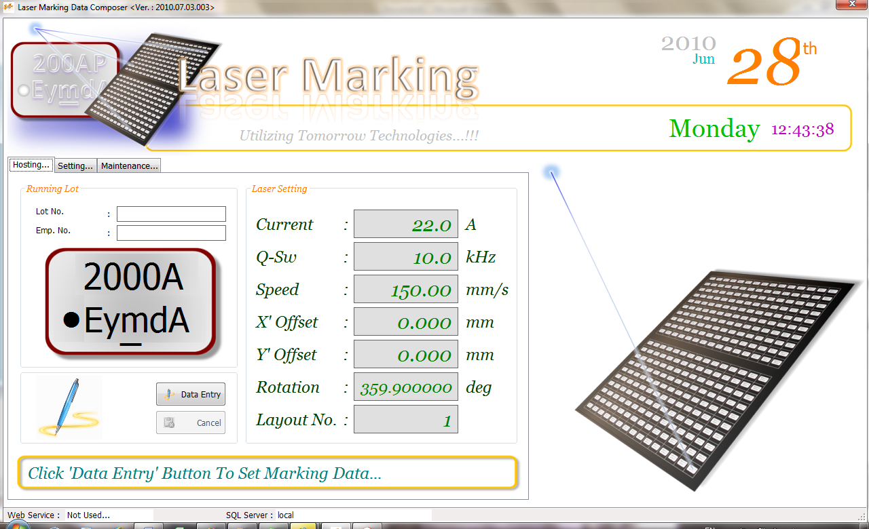In spite of making the system even better, scalable and stable. Machine Improvement (MI) had taken a step in advance to re-engineering the entire system based on the FC Laser Marking Platform which utilizing newer technologies. The system is targeted to be able to continue run on Windows 2000 environment, Windows XP 32 bits as well as 64 bits and Windows 7 ‘s all versions.

By taking away the software that runs separately on the same machine, which is the DLL (Dynamic Link Library), is making the system easier to deploy and implement as well as maintenance. Another advantage by taking the DLL away from the system is the significantly reduce the Memory usage which in return makes the entire system more effective and efficient.

At last but not least, some computer viruses spread through the DLL deployment in distributed system such as the Laser Marking Barcode System. In the case of distributed system, newer version DLL are always distribute through the network from a core server which in returns open an security hole for the hijacker software.

In perspective of maintenance, the system would face critical breakdown due to the damage to the computer system hard drive. The system served multiple of the product type, each product tight to a parameter setting which is to be posted to the Laser Marker for presetting purposes. It could certainly a nightmare to search and reset all the parameter within a short period of time.

*The Solution Pathway*

The newer version of the Barcode System is truly network implemented platform. The system was being tight to an *Internet Information Server (IIS)* for application distribution through Web Services and *a SQL Server* for data distribution.

The IIS server is hosting a service which distributes an application through the SOAP (Simple Object Activation Protocol) messaging. This is completely different compare to the implementation of DLL which runs on the same CPU. The application hosted by the IIS is being handled and executed by the IIS itself, which means, a piece of software is being break down into a small piece of components and runs under multiple CPU. Apparently, the entire system would more stable with less memory utilization.

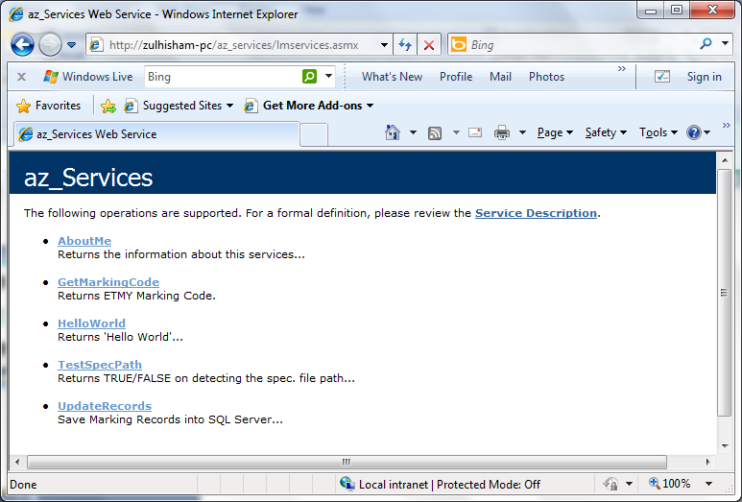In such cases, a smaller foot print of the operating system would make the system alive such as the Windows Embedded Operating System which is proven to be more robust for industrial automation purposes. With the implementation of the Windows Embedded, system recovery would be as easy as ABC. (MI Rules ~ Technologies Makes Things Simple).

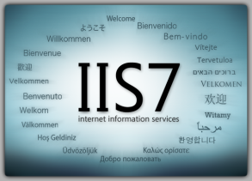

Even more interesting is… The services can be used by an application from multiple platforms such as Mac, Unix, Linux and etc… Regardless of what type of software used to develop the application and what type of operating system a system is powered by. The service is free to use.

With according to MI rules (Technologies Makes Things Simple). MI is developing the system which is fully Plug & Play. The maintenance personnel are only required to copy and paste the entire operating system (Windows Embedded) from the iM-TEST software control system into the target system. And the less of the critical tasks will be handled by the iM-TEST manager.

The pathway to this success is the utilization of SQL server which is used to distribute application setting, parameters and Windows Registry Setting.

Throughout the implementation of Network based application. The Laser Marking Barcode System has significantly stream down it size as much as possible which required less hard drive space and less memory usage. Figure below illustrated the entire system architecture.

3

**Retrieve & Update Marking Records**

Checking marking records database hosted by SQL

IIS Server

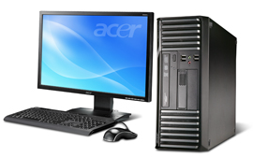



**SOAP Respond**

Marking character generated at the IIS server is post back to the Marking Workstation.

4

SQL Server

5

**Parameter Setting**

The Parameter settings were being retrieved directly from the SQL Server.

**SOAP Request**

A Request sent to the IIS Server to form marking character.

2



1

**Data Entry Level**

The operator scans the LPR data into the system using Barcode Sacnner.

Barcode System on Laser Marking Workstation

